**LEBANESE AMERICAN UNIVERSITY**

**USAID – HIGHER EDUCATION SCHOLARSHIP PROGRAM**

**HES - Volunteering Program Verification Form**

This form is to be used to document volunteering hours. If a student volunteers for multiple organizations, a separate form must be used for each organization. **This form must be turned in by the 28th of each month, the latest.**

I certify that the scholar Aline Diab completed a total of 12 hours of service at InnovaThrive.

The hours were completed hours as per the below:

Hours # 4 (date) _2/12 – 6/12_ (initials of supervisor) __A.K.___

Hours # 4 (date) _9/12 – 13/12_ (initials of supervisor) __A.K.___

Hours # 2 date) _16/12 – 20/12 (initials of supervisor) __A.K.___

Hours # 2 date) _23/12 - 27/12 (initials of supervisor) __A.K.___

Brief description of the activities the scholar performed or participated in:

Secretary of the CEO, Aline coordinates appointments by communicating with the CEO and the other party, as well as doing the weekly calendar for the CEO and sending emails.

Written feedback about the scholar’s performance:

Aline’s role as the CEO’s secretary demonstrated strong organizational skills, managing appointments and communications efficiently. Her work in maintaining the CEO’s weekly calendar and email correspondence was essential to smooth operations.

Please rate the overall performance of the scholar at your organization:

|  |  |  |  |
| --- | --- | --- | --- |
|  | Mastery (5) | Proficient (3) | Emerging (1) |
| **Problem solver** | X |  |  |
| **Engaged & Committed** | X |  |  |
| **Open-minded & multicultural** | X |  |  |

Signature

& stamp

__________________________

_

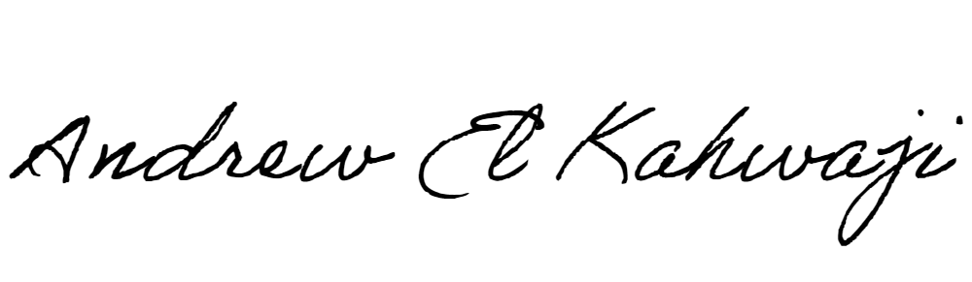

Printed Name _Andrew El Kahwaji_

Date __26/12/2024___

Email __andrew.lifesculptor.coo@gmail.com __

Phone __+961 71 914 378__